ANALYSIS OF SUPPLY AND DEMAND OF TOURISM PRODUCTS IN SANUR BEACH BALI

Muhammad Ridla^{1*}, Michael Rudolfus Sawu²

*Muhammad Ridla
^{1,2}Udayana University, Bali, Indonesia, Email: ridla.2281011004@student.unud.ac.id

ABSTRACT

Supply and demand are vital aspects in the development of the tourism sector. Comprehensive considerations will greatly determine the direction of the development of the tourism sector. This study aims to analyze the components of tourism products, tourism supply, and demand at Sanur Beach. Qualitative research with a descriptive qualitative approach was used in this study. The in-depth research method involved informants such as tourism managers, tourists, and other tourism practitioners at Sanur Beach. The data analysis method used was qualitative description. This study found that the provision of tourism product components, supply, and demand are categorized as good. However, it is necessary to maintain and improve their development in the future. The implication of this research is to enhance the development of supply and demand in order to improve the quality of tourism products. This study contributes to the discourse on the development of coastal tourism attractions.

Keywords: Components Of Tourism Products, Supply Tourism Products, Demand Tourism Products, Sanur Beach.

INTRODUCTION
Compared to other economic sectors, tourism is a fast growing industry. As a developing country, Indonesia is also one of the countries that is very active in developing the tourism sector. In addition to having great potential such as oil, natural gas, coal, and others, Indonesia also has enormous potential in developing its tourism sector (Rahma, 2020). Culture and natural beauty are valuable assets in tourism development. Tourism development includes all coordinated activities and efforts to attract tourists, provide necessary facilities, goods and services to serve tourists (Pitana, 2019). Tourism activities and development should include all aspects of community life, including transportation, accommodation, tourist attractions, food and baverage, souvenirs, etc. These efforts aim to encourage and increase the flow of both domestic and foreign tourists, thereby allowing the domestic economy to grow and develop (Yoeti, 2002).
Bali is one of the provinces in Indonesia that is actively developing its tourism industry. Tourism is one of its main sectors, as Bali lacks natural resources such as coal, oil, and natural gas found in other regions. The establishment of Hotel Bali Beach in the 1960's had a significant impact on the Sanur area. Sanur has become a famous and popular tourist destination in Bali (Sukardika, 2004). The popularity of the magic power has spread worldwide, attracting tourists to enjoy the attractions in the area. Tourists visiting the tourist attractions range from local residents in the Bali province area, domestic tourists, and foreign tourists. Foreign tourists come from various parts of the world, including countries from Europe, America, Africa, Australia, and Asia. However, the majority of tourists visiting this region still come from Asian mainland countries, rather than from other continents (BPS, 2021).
Sanur Beach is one of the tourist destinations in Denpasar. The coastal area is interesting to study because it has the potential to become a center of marine recreational activities that are highly favored compared to other tourist areas. (Gutama & Sunarta, 2011) In their research report, they stated that Sanur Beach has white sand and a wide coral reef that can protect it from large waves from the open sea. This coral reef creates a calm water atmosphere that is suitable for various enjoyable water activities such as glass bottom boats, banana boats, parasailing, snorkeling, spearfishing, windsurfing, kite surfing, and others (Darmana & Suarsana, 2016). Sanur is a resort destination specially developed to attract elite tourists from their home countries. They visit the island of the gods and choose the Sanur beach area as their preferred place of stay and fully enjoy their vacation. The desired accommodation for their needs is an international standard hotel. The description can certainly be seen from the characteristics of the tourists themselves. This condition is somewhat different from the tourist resorts that are developing in Kuta, Nusa Dua, Ubud, and other tourist areas in Bali (Darmana & Suarsana, 2016).
Similarly, the Sanur tourist area is currently one of the National Strategic Tourism Areas (KSPN) in Bali (Gutama & Sunarta, 2011). The establishment of KSPN is a policy of the central government related to the regulation and development of tourism throughout the country. KSPN provides guidelines for determining strategically important tourist areas as national tourist attractions, making them appealing to tourists. KSPN provides guidelines for determining strategically important tourist areas as national tourist attractions, making them appealing to tourists. KSPN provides guidelines for determining strategically important tourist areas as national tourist attractions, making them appealing to tourists (Waruwu, 2022). Therefore, regulations related to the development and organization of tourism as a smokeless industry in Bali, particularly in the Sanur area, should be based on the exotic natural and cultural panorama. It is only this potential that the Sanur community, including other areas in Bali, has to be innovatively and creatively developed in order to optimize (Gutama & Sunarta, 2011).
The Sanur Beach area has great potential and offers various marine recreational activities that can attract visitors back to the beach. Despite environmental pollution, destruction, and social problems, research is needed to determine the tourist attractions that influence tourists' interest in visiting Sanur Beach. Despite environmental pollution, destruction, and social problems, research is needed to determine the tourist attractions that influence tourists' interest in visiting Sanur Beach. Despite environmental pollution, destruction, and social problems, research is needed to determine the tourist attractions that influence tourists' interest in visiting Sanur Beach. The purpose of this research is to identify the 4A components in the tourism products available at Sanur Beach and to determine the supply and demand of these components. The aim is to provide a positive overview for the development of the Sanur Beach marine tourism destination and to share benefits with stakeholders. This is in order to build a more environmentally friendly and socially sustainable tourism destination through the interests and activities of tourists.
According to Undang-Undang No. 10 tahun 2009, a tourism destination is a geographic area located within one or more administrative regions that contains tourist attractions, public facilities, tourism facilities, accessibility, and interrelated communities, all of which complement the development of tourism. (Cooper, 1999) suggests that there are several essential components or elements that a destination must possess, including: a) Attractions are significant components that can draw tourists, including natural and cultural attractions, as well as man-made ones. They are related to the things that tourists want to see and do when traveling to a destination. b) Accessibility refers to the means and infrastructure used by tourists during their travels. These means can include transportation such as cars, motorcycles, airplanes, trains, ships, and others. Meanwhile, the infrastructure includes roads, train stations, airports, and others. The presence of excellent accessibility is crucial for the sustainability of tourism. Accessibility is used by tourists when traveling to, during, and leaving their destination. c) Amenities refer to all supporting facilities that can meet the needs and desires of tourists during their stay at a destination. Amenities come in various forms, such as dining places, accommodations, conventional stores, and so on. The presence of adequate amenities at a tourist destination can enhance tourists' satisfaction while traveling. d) Ancillary refers to an organization, facility, or individuals who manage the tourist destination. The presence of complete ancillary services is a plus point for a destination as it can enhance the safety, satisfaction, and comfort of tourists during their visit. Ancillary services come in the form of health clinics, police stations, places of worship, tourism organizations, information services, and others.
According to (Sukirno, 2005) demand is the quantity of goods requested by buyers in the market at various price levels. Meanwhile, (Salma & Susilowati, 2004) define market demand for a resource as the sum of all demands for various uses of the resource. In the tourism sector, demand affects all other sectors of the economy, including individuals, small businesses, medium-sized businesses, private companies, and the government (Sinclair & Stabler, 1997). (Yoeti, 2002) This text outlines the unique characteristics of tourism demand as compared to the demand for goods and services in general, a) Strongly influenced by the seasons; b) Centered on certain places; c) Depending on the size of the income; d) Compete with demand for luxury goods; e) Subject to free time; f) Depending on transportation technology; g) Number of members in the family; h). Accessibility. (Yoeti, 2002) also describes the factors that can affect tourism demand, including: 1) General Demand Factor, namely the factor of the presence of demand in general such as the power to buy based on tourist income, the size and population growth, industrialization which results in an even income structure of the community. motivation to travel, and opportunities to travel. 2) Factors Determining Specific Demand, namely factors that affect special demand in a tourist destination, such as prices, tourist attractions, ease of visiting, information, and destination image.
(Gilarso, 2003) Supply is the amount of a particular good to be sold at various possible prices over a certain period of time. In tourism, offers can show tourist attractions, services, and goods that are expected to attract tourists (Wahab, Crampon, Gromang, & Rothfield, 1992). Next, (Gunn, 2000) Describe the components of supply in the tourism sector into five parts, including: a) Attractions, which are the main attractions of tourists in traveling. Attractions have the main function as an allure and stimulant for tourists to travel, as well as a giver of tourist satisfaction. b) Services, namely facilities provided to tourists, including restaurants or restaurants, travel agents, and souvenir shops that serve regional specialties. c) Promotion, which is an important activity in the development of tourism that can be carried out by the government or the private sector. This promotional activity can be done by placing advertisements through public relations activities or providing intentions, such as discounted entrance tickets for tourists. d) Transportation, which is an important component in the tourism system that acts as accessibility or ease of reaching a tourist destination. e) Information, which is a component that includes travel and other information, which can be presented in the form of maps, user manuals, articles in magazines, brochures or via the internet.
METHOD
According to (Bungin, 2001) Research methods are scientific ways of obtaining data for specific purposes and uses. Scientific means research activities that are based on scientific characteristics, that is, rational, empirical and systematic. The research used in this study used qualitative research. Researchers choose to use this method because researchers need to see directly the existence or condition of the research location that has been chosen. According to (Sugiyono, 2016), The qualitative descriptive method is a research approach where the data collected is in the form of words, images and not numbers. This data can be obtained from interviews, field notes, photographs, personal documentation, personal notes and other documentation. This research uses two stages, namely, the first stage is to formulate problems regarding the components of Sanur Beach tourism products using data collection methods, namely observation and documenting the results of direct observation. To strengthen the results of direct observation and documentation, interviews were conducted with communities directly involved in the management of Sanur Beach. According to (Sugiyono, 2016) Purposive sampling is a sampling technique with certain considerations. In this case, they can provide a clear picture and information related to the tourist attraction of Sanur Beach. The results of data collection are analyzed with aspects (4A) that must be considered in tourism demand and supply, where aspects of tourism product offerings consist of attractions, facilities, accessibility, and ancillary (additional services). Descriptive analysis was conducted to determine the components of tourism and attractions in Sanur Beach as a tourist attraction.
RESULT AND DISCUSSION
Based on the purpose of the study, this study focuses on identifying tourism products that exist in Sanur Beach today. The analysis is based on the concept of 4A, the concept of supply and the concept of demand as components of tourism products which include attractions, accessibility, facilities, and additions. Data was collected through interviews, observation, and content analysis. The results and discussion are presented below.
- Attraction
- Sunrise View
For tourists who want to enjoy their vacation time by doing relaxing and relaxing activities, watching the sunrise view is the right choice. As a beach known as The Sunrise of Bali, Sanur Beach has the best sunrise view on the island. Tourists can relax on the beach or in cafes and restaurants available in this tourist area while enjoying the view of the rising morning sun.
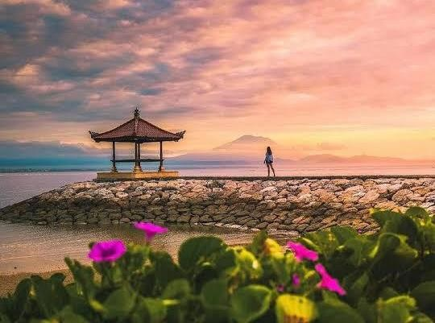

Figure 1. Portrait of sunrise at Sanur Beach
Source: Tripadvisor,2023
- Various Activities and Water Sports
Sanur Beach is known to have waves that are relatively calm and gentle. This causes a number of activities or water sports can be done by tourists in this tourist area comfortably, such as swimming and canoeing. In addition, tourists can also try other water sports such as diving at a depth of 5 to 7 meters. In carrying out this activity, tourists will have the opportunity to encounter various kinds of marine life such as coral reefs, stingrays, starfish, to sea lions. In addition, tourists can also feel the sensation of feeding some fish with the direction of a tour guide.

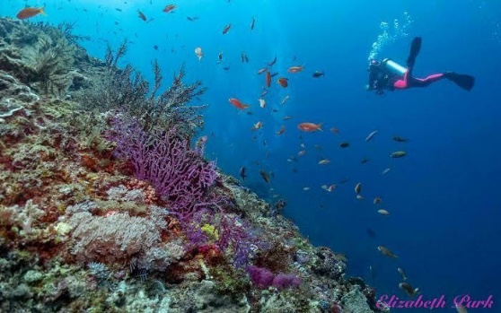

Figure 2. Portrait of a tourist diving in Sanur
Source: Traveloka, 2023
- Museum Le Mayeur
One of the interesting attractions that tourists should visit while in the tourist area of Sanur Beach is Le Mayeur Museum. This museum was founded in 1932 by a Belgian man named Le Mayeur. Mayeur is a painter who fell in love with a woman from Kelandis, Bali named Ni Pollok. At first, Ni Pollok was a traditional Balinese dancer who became one of the models in Le Mayeur's paintings. As time went by, the two fell in love and eventually married and settled together in Bali in 1935. Since then, Ni Pollok has always been one of Mayeur's main inspirations in painting. Mayeur built a house that was also used as his painting studio in the Sanur area, Now, the house building has been converted into a museum by the local government. The love story of Le Mayeur and Ni Pollok, along with dozens of paintings owned managed to become a special attraction for tourists who want to visit this museum.
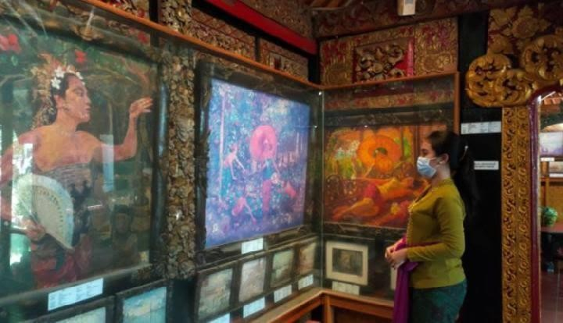

Figure 3. Le Mayeur Museum of Paintings
Source: Travel – Tempo.co, 2023
- Prasasti Blanjong
For tourists who have an interest and interest in historical tourism, one of the choices of attractions worth visiting is Pura Blanjong. This sacred area is located in Banjar Blanjong, Sanur. Apart from being a place of worship for Hindus, this temple keeps one of the oldest archaeological relics in Bali, namely the Blanjong Inscription. This inscription is estimated to have been made by a Balinese King named Sri Kesari Warmadewa in the 9th century, precisely in the year Caka 835 or 913 masehi. In the writing on this inscription, there are two languages used, namely Sanskrit and Old Balinese. When visiting this area, tourists are advised to wear appropriate clothing considering that this place is a sacred area, and ask a tour guide so that information about the history of the inscription can be conveyed properly.

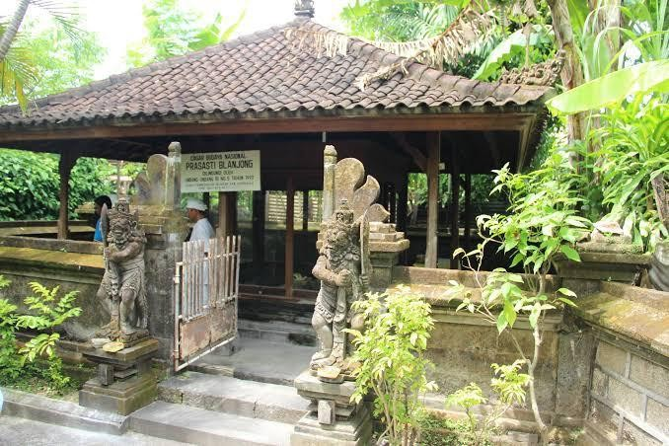

Figure 4. Location of Blanjong Inscription
Source: Researcher, 2023
- Amenities
Since the development of Sanur Beach as one of the main tourist destinations in southern Bali, various amenities are available to support local tourism activities, including:
- Restaurant and Cafe
As a popular tourist destination in southern Bali, various restaurants and cafes are present in the Sanur Beach Tourism Area with diverse menu choices. Tourists who want to try the taste of Balinese cuisine can visit two legendary Balinese restaurants, namely Warung Men Weti and Warung Mak Beng. Warung Men Weti is a dining place that sells Balinese culinary in the form of Nasi Campur with the main side dish of fried chicken, betutu chicken, and typical chili sauce. While Mak Beng is a place to eat that has been established since 1941 with a typical menu in the form of fish soup, fried fish, and chili paste. Both have become typical Balinese culinary icons in Sanur and are often visited by local and foreign tourists. In addition, there are also foods with foreign flavors such as Pizza, Spaghetti, Sushi, Gelato, and others scattered in a number of restaurants and cafes in this tourist area
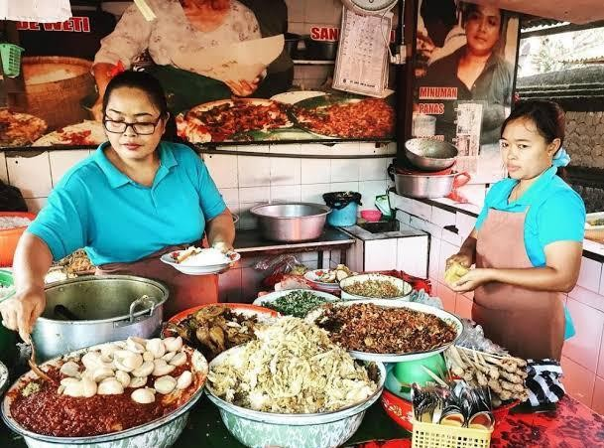

Figure 5. Men Weti Mixed Rice Stall, Sanur
Source: Traveloka, 2023
- Shopping Center
In order to support the needs of tourists while traveling on Lovina Beach, a number of shopping centers come with various products offered. Sindhu traditional market is one of the complete shopping centers providing the needs of tourists such as food, groceries, produce, clothing, to souvenirs. In addition, there are also modern shopping centers such as conventional stores that come with products from foreign brands such as snacks, liquor, and so on.

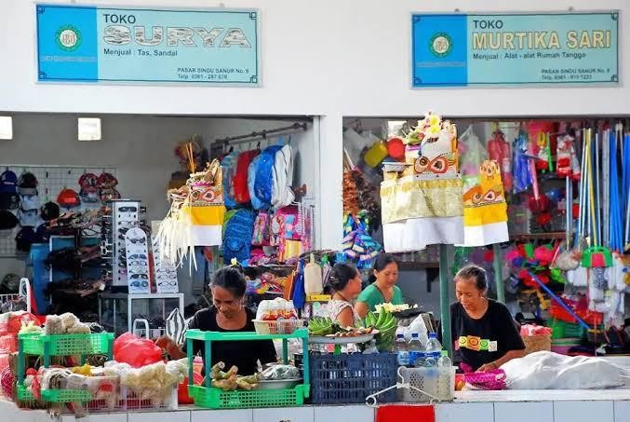

Pigure 6. Shindu Traditional Market, Sanur Beach Tourism Area
Source: Tripadvisor, 2023
- Entertainment Center
A number of entertainment centers are also present in the Sanur Beach tourist area as an alternative attraction that can be chosen by tourists. The entertainment center includes a bar and beach club with various interesting facilities such as live music activities, swimming pool access, restaurants, and cafes which are all in the same area. Another entertainment center is Sindhu Night Market which is a night market where dozens of local traders sell various merchandise such as food, clothing, to souvenirs.
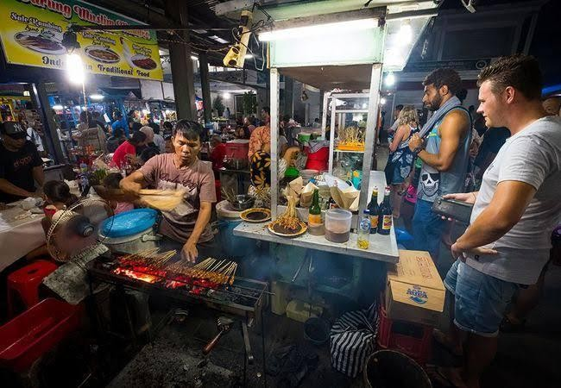

Figure 7. Portraits of tourists visiting Sindhu Night Market
Source: Researcher,2023
- Aksesibility
Sanur Beach has several efforts to improve accessibility for visitors with special needs. Here is some information about accessibility in Sanur Beach:
- Road Access
The road to Sanur Beach is quite wide and easily accessible by bicycles and pedestrians. There are several access roads that lead to this beach, making it easier for visitors to reach their destinations to enjoy the beach and restaurants around the beach.
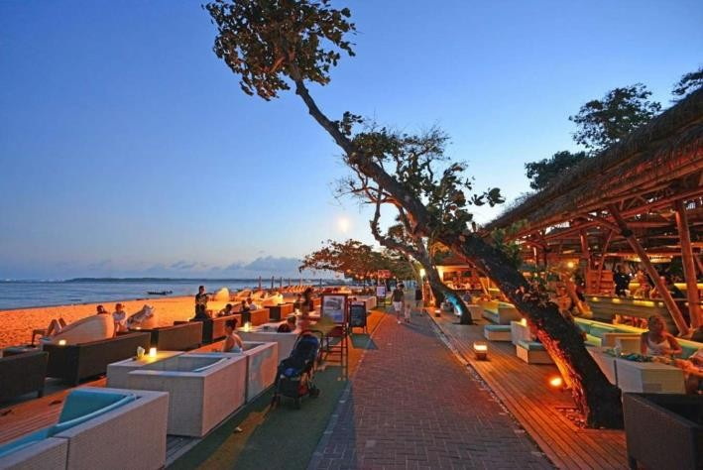

Figure 8. Trail access in Sanur Beach area
Source: Traveloka.com,2023
- Access for People with Disabilities
Several efforts have been made to improve accessibility for people with disabilities in Sanur Beach. Some areas on this beach have been equipped with flat paths and wheelchair friendly. There is also a parking area designated for vehicles carrying people with disabilities.
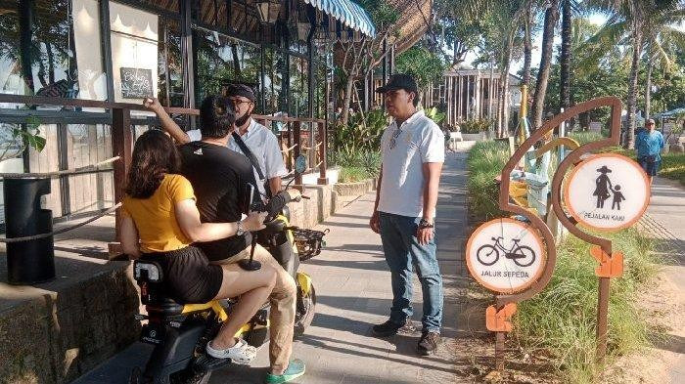

Figure 9. Portraits of tourists chatting with local people
Source: Tribunbali.com, 2023
- Ancillary
Ancillary is a supporting factor or additional facilities owned by tourist attractions, Sanur Beach itself has several additional facilities as follows:
- Accommodation
Sanur Beach offers a wide variety of lodging, from luxury hotels to more affordable villas and inns. Many inns in Sanur are equipped with additional facilities such as swimming pools, restaurants, spas, fitness centers, children's play areas, and Wi-Fi access.
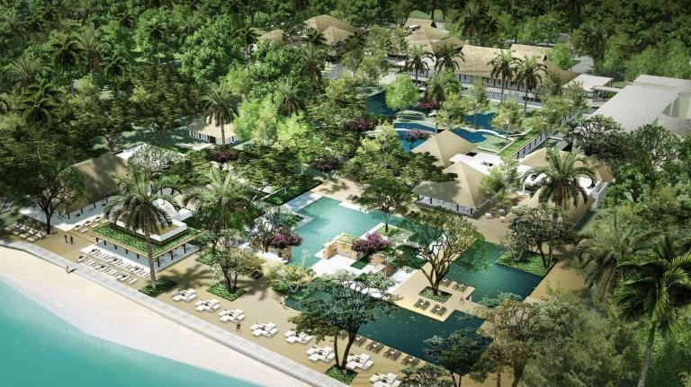

Figure 10. Portrait of Sanur Beach Tourism Area
Source: Tripadvisor.com, 2023
- Restaurants and food stalls,
Sanur Beach has a large selection of restaurants, cafes and food stalls serving local and international cuisine. You can find a wide variety of dishes ranging from fresh seafood to traditional Balinese dishes. Some restaurants may also offer live entertainment such as dance and music performances.
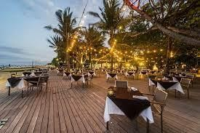

Figure 11. One of the tourist facilities in Sanur Beach
Source: Balidestiny.com, 2023
- Places of Worship
Sanur also has several places of worship, including Hindu temples and churches available for tourists and locals who wish to worship or attend religious activities.
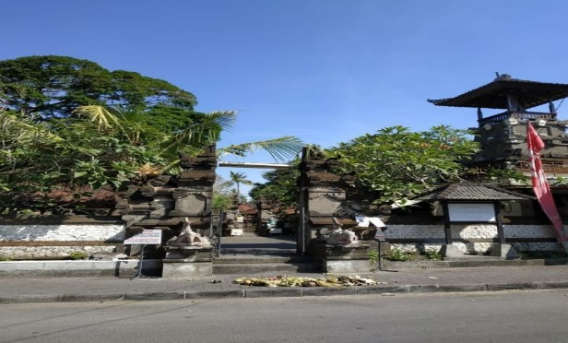

Figure 12. Temple as one of the places of worship in Sanur Beach Area
Source: Researcher, 2023
- Supply
Supply is the total amount of goods or services that will be sold or offered by producers at various price levels. In the law of supply, the amount of goods offered will always be directly proportional to the price. That is, if the price of goods rises, then the number of goods offered increases. Conversely, if prices fall, then the amount of goods offered will decrease, while Demand is the overall amount of goods and services that consumers want to buy at various price levels. In the law of demand says that the quantity of goods demanded will always be inversely proportional to the price. This means that if the price of goods increases, then the amount of goods demanded will decrease. Conversely, if the price of goods falls, then the amount of goods demanded will increase.
Furthermore, in tourism (Kotler & Armstrong, 2008) Present definitions of supply and demand in general. Supply is defined as a number of goods, products or commodities that are available in the market to be sold to people who need them. Demand is defined as a person's desire for a certain product or good. Bids include all products produced by a group of companies including tourism industry groups that will be offered to visitors, while demand refers more to the demand for goods or products to be purchased at a certain price followed by the power to buy (purcashing power). In the tourism industry, in general tourism offers include everything that a tourist attraction has to offer to actual visitors as well as potential visitors. (Paturusi, 2008) states that talking about recreation supply is talking about (1) what and how much can be given, (2) when it can be given and (3) to whom it can be given. Offers in tourism show a treasure trove of natural and man-made tourist attractions, services and goods that will approximately attract people to visit a particular country. According to (Wahab, Crampon, Gromang, & Rothfield, 1992) Tourism offers are characterized by three main distinctive features. First, tourism is an offering of services, so the products offered are impossible to hoard and must be utilized where the products are located. Consumers must go to the products offered. Second, the products offered are rigid so it is very difficult to change the target of use outside tourism. Third, tourism offers must compete fiercely with the supply of other goods and services because tourism has not become a basic human need.
Sanur Beach as one of the tourist attractions in the heart of Denpasar, is very easy to access by tourists because of its location very close to the city of Denpasar, as one of the most popular attractions, Sanur Beach has operated as an attraction that provides tourists with very complete facilities ranging from accommodation facilities, transportation, to tourist facilities to meet the needs of eating and drinking Sanur Beach has become a complete package for Tourists because there are so many tourism activities that can be done on Sanur Beach. The following tourism activities are offered (Supply) Sanur Beach as a tourist attraction: 1) Swimming, 2) Sanur water sport, 3) Jogging and cycling, 4) Seeing the sunrise view, 5) Sanur festival, 6) Sanur village festival, 7) Kite festival, and Balinese art festival, 8) Seawalker, 9) Snorkeling, 10) Scuba diving, 11) Canoeing.
The tourism supporting facilities found on Sanur Beach are as follows: 1) Accommodation (Hotel, villa, resort, homestay), 2) Gazebo, 3) Parking area, 4) Public toilet, 5) Food stall, restaurant, coffee shop, 6) Interesting photo spots, 7) Pier, 8) Area for cycling, 9) Money changer, 10) Beauty salon and spa facilities, 11) Souvenir shop, 12) Tourist information center, 13) Directional facilities, 14) Car and motor bike rent, 15) Places of worship, 16) Garbage cans, 17) Hospitals, 18) Disability friendly facilities, 19) Availability of green open space (RTH).
- Demand
Tourism facilities in Sanur Beach according to the perspective of tourists are already in a good categoti. However, from the existing facilities in Sanur Beach, it is necessary to improve several public facilities such as vehicle parking lots, trash cans, places of worship, and public toilets. The improvement of the facilities in question is to add and manage well some of the existing facilities in the Sanur Beach area. Such a phenomenon that occurs is that there are often congestion caused by the mobility of tourists in the Sanur beach area. So that it can be an input for Sanur Beach managers to pay attention to the arrangement of the Sanur Beach area which is more ideal. The following is a table of demand and supply in Sanur Beach.
Table 1. Demand and Supply in Sanur Beach
Conformity | Item | Supply | Demand
Tourist Attractions | Swim | Good Conditions | It is very important to work on the condition
Tourist Attractions | Water Sport | Good Conditions | It is very important to work on the condition
Tourist Attractions | Jogging &; Cycling | Good Conditions | It is very important to work on the condition
Tourist Attractions | See the sunrise view | Good Conditions | It is very important to work on the condition
Tourist Attractions | Sanur Festival | Seasonal | It is very important to work on the condition
Tourist Attractions | Sanur Village Festival | Seasonal | It is very important to work on the condition
Tourist Attractions | Kite Festival | Seasonal | It is very important to work on the condition
Tourist Attractions | Bali Arts Festival | Seasonal | It is very important to work on the condition
Tourist Attractions | Sea Wolker | Good | It is very important to work on the condition
Tourist Attractions | Senorkelling | Good | It is very important to work on the condition
Tourist Attractions | Scuba Diving | Good | It is very important to work on the condition
Tourist Attractions | Canoeing | Good | It is very important to work on the condition
Accessibility | Accessibility to Sanur Beach (Public Transportation and Private Transportation) | Easy Enough | There needs to be an improvement in the comfort aspect
Facilities | Accommodation (Hotel,Villa, Resort, Home Stay) | Available | It needs to be maintained in condition and propagated
Facilities | Gazebo | Available | It needs to be maintained in condition and propagated
Facilities | P arking | Available | It needs to be maintained in condition and propagated
Facilities | T oilet | Available | It needs to be maintained in condition and propagated
Facilities | Food Stall, Restaurant, Coffee Shop | Available | It needs to be maintained in condition and propagated
Facilities | Interesting Photo Spot | Available | It needs to be maintained in condition and propagated
Facilities | Dock | Available | Need to be maintained in condition
Facilities | Cycling area | Available | Need to be maintained in condition
Facilities | Money Changer | Available | Need to be maintained in condition
Facilities | Beauty facilities (salon &; spa) | Available | It needs to be maintained in condition and propagated
Facilities | Souvenir | Available | It needs to be maintained in condition and propagated
Facilities | Tourist Information Center | Available | Need to be maintained in condition
Facilities | Direction Indicator | Available | It needs to be maintained in condition and propagated
Facilities | Car & Motor Bike Rent | Available | Need to be maintained in condition
Facilities | Places of Worship | Available | It needs to be maintained in condition and propagated
Facilities | Trash Can | Available | It needs to be maintained in condition and propagated
Facilities | Hospital | Available | Need to be maintained in condition
Facilities | Accessible Facilities | Available | Need to be maintained in condition
Facilities | Green Open Space | Available | Need to be maintained in condition
Source: Researchers 2023
CONCLUSIONS
Based on the text provided, the following conclusions can be drawn: Supply in the context of tourism includes everything that a tourist attraction offers to visitors, including natural attractions, cultural attractions, man-made attractions, services, and goods that attract people to visit a country or tourist destination. Demand in the context of tourism is a person's desire for a certain product or item, in this case it is the desire to visit a particular tourist spot. Demand is influenced by price and purchasing power. The amount of demand tends to be inversely proportional to price, meaning that if prices rise, demand will tend to fall, and conversely if prices fall, demand will tend to increase.
Capital tourist attractions that attract tourist arrivals in general can be categorized into three, namely natural attractions, cultural attractions, and human attractions themselves. These attractions can be developed and utilized both in their original place and elsewhere (in situ and ex situ). Sanur Beach is one of the popular tourist attractions with various tourism activities offered to visitors. Activities include swimming, water sports, jogging and cycling, enjoying the sunrise view, festivals, and arts and cultural activities. Sanur Beach also provides various tourism supporting facilities, including accommodation, public toilets, places to eat, parking areas, interesting photo spots, piers, tourist information, and so on. Although tourism facilities in Sanur Beach are considered good, there are several public facilities that need to be improved, such as vehicle parking lots, trash cans, places of worship, and public toilets. The increase in this facility is expected to improve the tourist experience and arrange the Sanur Beach area to be more ideal. The conclusion highlights the importance of supply and demand in the tourism industry, as well as the need for the development and improvement of facilities to increase tourist attraction and satisfaction.
BIBLIOGRAPHY
Anonim. (2009). Undang-Undang Republik Indonesia Nomor 10 Tahun 2009. Tentang Kepariwisataan.
BPS. (2021). Denpasar Selatan Dalam Angka. Denpasar: Badan Pusat Statistik Kota Denpasar.
Bungin, B. (2001). Metodologi Penelitian Sosial: Format-format Kuantitatif dan Kualitatif. Surabaya: Airlangga University Press.
Cooper, C. (1999). Tourism: Principles & Practise. New Jersey: Longman.
Darmana, K., & Suarsana, I. N. (2016). Optimalisasi Potensi Kawasan Pantai Sanur Memasuki Pasar Bebas Global Asean Economic Community (MEA). Denpasar: Universitas Udaya.
Gilarso, T. (2003). Pengantar Ilmu Ekonomi Makro. Yogyakarta: Kanisius.
Gunn, C. A. (2000). Tourism Planning. New York: Tylor & Francis.
Gutama, I. G., & Sunarta, I. N. (2011). Evaluasi Perkembangan Wisata Bahari di Pantai Sanur. Denpasar: Prog. Pascasarjana, Universitas Udayana.
Kotler, P., & Armstrong, G. (2008). Principles of Marketing. London : Pearson Education Limited.
Paturusi, S. A. (2008). Perencanaan Kawasan Pariwisat. Denpasar: Universitas Udayana.
Pitana, I. G. (2019). Pengantar Ilmu Pariwisata. Yogyakarta: Andi & L.
Rahma, A. A. (2020). Potensi Sumber Daya Alam dalam Mengembangkan Sektor Pariwisata di Indonesia. Jurnal Nasional Pariwisata, 12(1), 1-8.
Salma, I. A., & Susilowati, I. (2004). ANALISIS PERMINTAAN OBJEK WISATA ALAM CURUG SEWU, KABUPATEN KENDAL DENGAN PENDEKATAN TRAVEL COST. Jurnal Dinamika Pembangunan (JDP), 1(2), 153-165.
Sinclair, M. T., & Stabler, M. (1997). Economics of Tourism. London: Routledge.
Sugiyono. (2016). Metode Penelitian Kuantitatif, Kualitatif, dan R&D. Bandung: Alfabeta.
Sukardika, K. (2004). Menata Bali Kedepan : Kebijakan Kultural, Pendidikan & Agama. Denpasar: Bali Media Adhikarsa.
Sukirno, S. (2005). Pengantar Teori Makro Ekonomi. Jakarta: Rajawali Press.
Wahab, S., Crampon, L. J., Gromang, F., & Rothfield, L. M. (1992). Industri Pariwisata. Jakarta: Pradnya Paramita.
Waruwu, R. S. (2022). ANALISIS DAYA TARIK WISATA TERHADAP MINAT BERKUNJUNG ULANG WISATAWAN (STUDI KASUS KAWASAN PANTAI SANUR). Jurnal Mahasiswa Pariwisata dan Bisnis, 01(09), 2395-2405. doi:10.22334/paris.v1i9
Yoeti, O. A. (2002). Perencanaan dan pengembangan pariwisata. Jakarta: Pradnya Paramita.

