Analysis Of The Influence Of Tourism Facilities On Visitor Loyalty To Transera Waterpark Bekasi

Brigita Cahyani Erwan
Hospitality and Tourism Study Program, Bunda Mulia University, Indonesia

Vishnuvardhana S. Soeprapto
Hospitality and Tourism Study Program, Bunda Mulia University, Indonesia

Corresponding E-mail Address 10 brigitacahyanie@gmail.com

ABSTRACT

This research aims to find out how tourist facilities affect visitor loyalty to Transera Waterpark Bekasi City, based on the urgency of this research, namely increasing awareness of Transera Waterpark regarding the importance of having good and well-maintained tourist facilities. In conducting this research, researchers used quantitative research methods, namely by collecting samples using questionnaires and samples were processed using several testing techniques, namely data quality tests consisting of Validity Tests and Reliability Tests, classic assumption tests consisting of Normality Tests, Linearity Tests and Heteroscedasticity Test, Descriptive Analysis Test, hypothesis test consisting of Simple Linear Regression Test, t-test, Coefficient of Determination Test and Correlation Test. After conducting the test, it can be concluded that tourist facilities have a significant effect on visitor loyalty at Transera Waterpark Bekasi with a large influence of 41.8% and visitor perceptions of tourist facilities are in the high or good category

KEY WORDS : Tourist Facilities, Visitor Loyalty, Attractions, Waterpark

INTRODUCTION

A tourist attraction is a location that is visited because of its beauty, can be a destination for tourism activities, a pleasant place to spend a long time to feel satisfaction at the tourist attraction, provides quality services, and creates beautiful memories during a tourist trip according to ( Pariyanti & Buchori, 2020). Tourist attractions are divided into 2 types, namely natural and man-made. Natural tourist attractions are tourist attractions that utilize the capabilities of natural resources either naturally or after cultivation efforts. Meanwhile, artificial tourist attractions are tourist attractions created intentionally by humans. In order for a tourist attraction to develop, the tourist attraction must have 4 tourism components, which are called 4A, namely Attraction or tourist attraction, Amenities or facilities, Accessibility and Ancillary or institutional. That is the 4A component of tourism based on Cooper's (1995) theory in (Husain & Santoso, 2023). Apart from having 4A, it is also necessary to have good quality of the tourist attraction. According to ( Albar Alaydrus et al., 2020) Facilities are physical assets that are available before a service can be provided to users. Facilities include everything that makes it easier for consumers to fulfill various needs related to the service offering.
The quality of a tourist attraction is not only seen from the condition of the tourist attraction, but is also assessed in terms of facilities, service, service, marketing and also in terms of accessibility that can support the tourist attraction. Visitor assessments can also be a reference in developing tourist attractions in the future. When building a tourist attraction, it should be adjusted to the desires and needs of visitors, so that visitors can feel satisfied and in line with their expectations of the tourist attraction. In this way, visitors will stay at the tourist attraction for a longer period of time and can visit the place again. Tourist attractions are also closely related to tourist attractions, because attractions are the basis of tourism itself. And the attractiveness of a tourist attraction can attract visitors' interest in visiting the tourist attraction. Without an attraction at a certain tourist attraction or place, tourism will be difficult to develop. A tourist attraction must improve its quality so that it becomes better and gets a positive image. Because the image of the quality of a tourist attraction can be a reference to see the level of excellence of a tourist attraction. The quality of a tourist attraction is one of the determining elements in attracting visitors. Apart from that, the availability of facilities is also important in providing visitors' needs while they are away from their place of residence. Having complete facilities can also become a magnet for visitors, because their needs and interests can be met by a tourist attraction. So, to become a popular tourist attraction, it also needs to have complete facilities. According to ( Septiawan, 2021) , tourist facilities include various facilities and infrastructure that provide comfort and facilitate the implementation of recreational activities, both in terms of management by tourists, managers and the community. Thus, it can be concluded that tourist facilities include all forms of facilities and infrastructure that facilitate recreational activities, management and community participation in tourism activities.
Having complete or complete facilities creates tourist loyalty towards a tourist attraction because positive experiences with facilities can create tourist loyalty and tourists who are satisfied with the facilities tend to be more likely to return to the same tourist attraction, making a continuous contribution to the tourism industry in the tourist attraction. According to (Payangan, 2014) quoted by ( Abdul Aziz et al., 2020) , Visitor loyalty is the percentage of customers who remain loyal, who wish to continue using a service or product, and have the intention to recommend the product or service to others. In the tourism business according to (Hasan, 2015) quoted by ( Abdul Aziz et al., 2020) , tourist loyalty can be measured through three factors, namely: 1) Intention to continue buying the same product in the future (long-term aspect), 2) Greater purchase rates over longer visits, and 3) Willingness to recommend the product to others. Visitor loyalty is one of the crucial factors for the continuity of a company's business (Amalia & Sudibyo, 2020).
One tourist attraction that can be looked at in terms of facilities is the Transera water park. Transera Waterpark is located in Harapan Indah, Bekasi City.
Transera Waterpark is a water recreation park with an exotic African feel. Transera water park is one of the largest tourist attractions in Jabodetabek with an area of 6.3 hectares. Transera Waterpark is a type of man-made tourist attraction. This recreation park was built starting in June 2012 and cost more than IDR 150 billion. Transera waterpark has 23 rides, consisting of crazy cone, racer slide, water slide, wave pool, cowboy town, and Zambesi river or current pool which has a depth of 90 cm. And there is a land ride or dry park covering an area of 2 hectares containing various dry games, boom boom car, lantern park and other rides. This Transera water park used to be a tourist attraction that was busy with visitors, but according to the author's observations, over time, this Transera water park experienced a decline in visitors and until the Covid-19 outbreak, the Transera water park was closed and not operating at all. On Saturday, January 2 2021, Transera finally reopened and was selling tickets at a price of IDR 30,000, but with Transera having reduced the price to such an extent, it still couldn't be as busy as before. Transera Waterpark operates every day from 10.00 am to 5.30 pm, but on Saturdays and Sundays Transera Waterpark opens earlier, namely opening at 8.30 am. Currently ticket prices are sold starting from IDR 35,000 for Friday to IDR 80,000 on Saturday and Sunday. for Monday to Thursday tickets are sold at IDR 65,000 ( Transera Waterpark , nd)
According to the experience of several visitors who came to Transera Waterpark, they felt happy and also enjoyed the activities at Transera Waterpark, however, many tourists still felt dissatisfied because there were still several facilities that were considered poor and unsupportive. Examples include several rides that are not operational, a lack of bathrooms, slippery floors around the swimming pool, a lack of maps to guide the way and know where the rides are and tap water that flows slowly and slowly, as well as dirty bathrooms or toilets.

METHODOLOGY
This research uses quantitative research methods. The subjects of this research were visitors to Transera Waterpark Bekasi. The data in this research comes from primary data and secondary data. Primary data is in the form of questionnaires or questionnaires , while secondary data is in the form of structured observations and documents. The population in this study were visitors to Transera Waterpark Bekasi 2023, totaling 100 people. The data is processed using several testing techniques, namely data quality testing consisting of Validity Test and Reliability Test, classical assumption testing consisting of Normality Test, Linearity Test and Heteroscedasticity Test, Descriptive Analysis Test, hypothesis testing consisting of Simple Linear Regression Test, Test- t, Coefficient of Determination Test and Correlation Test .

RESULTS AND DISCUSSIONS

Data Quality Test
In testing the quality of this data, researchers used the IBM SPSS Statistics 25 application to make it easier to process the respondent data that had been obtained. The following is an analysis of the results of the data quality test using the IBM SPSS Statistics 25 application:
The following are the results of the validity test of each research variable based on data processing using SPSS:
Table 1. Validity Test
Variable | Question | R count | Information
Tourist Facilities  (X) | P1 | 0.621 | Valid
Tourist Facilities  (X) | P2 | 0.673 | Valid
Tourist Facilities  (X) | P3 | 0.539 | Valid
Tourist Facilities  (X) | P4 | 0.663 | Valid
Tourist Facilities  (X) | P5 | 0.677 | Valid
Tourist Facilities  (X) | P6 | 0.657 | Valid
Tourist Facilities  (X) | P7 | 0.716 | Valid
Tourist Facilities  (X) | P8 | 0.576 | Valid
Tourist Facilities  (X) | P9 | 0.652 | Valid
Tourist Facilities  (X) | P10 | 0.691 | Valid
Tourist Facilities  (X) | P11 | 0.713 | Valid
Tourist Facilities  (X) | P12 | 0.642 | Valid
Tourist Facilities  (X) | P13 | 0.638 | Valid
Tourist Facilities  (X) | P14 | 0.705 | Valid
Tourist Facilities  (X) | P15 | 0.645 | Valid
Tourist Facilities  (X) | P16 | 0.697 | Valid
Tourist Facilities  (X) | P17 | 0.710 | Valid
Tourist Facilities  (X) | P18 | 0.670 | Valid
Tourist Facilities  (X) | P19 | 0.735 | Valid
Tourist Facilities  (X) | P20 | 0.697 | Valid
Tourist Facilities  (X) | P21 | 0.783 | Valid
Tourist Facilities  (X) | P22 | 0.719 | Valid
Tourist Facilities  (X) | P23 | 0.748 | Valid
Tourist Facilities  (X) | P24 | 0.597 | Valid
Tourist Facilities  (X) | P25 | 0.695 | Valid
Tourist Facilities  (X) | P26 | 0.656 | Valid
Tourist Facilities  (X) | P27 | 0.555 | Valid
Tourist Facilities  (X) | P28 | 0.655 | Valid
Tourist Facilities  (X) | P29 | 0.600 | Valid
Tourist Facilities  (X) | P30 | 0.732 | Valid
Tourist Facilities  (X) | P31 | 0.774 | Valid
Tourist Facilities  (X) | P32 | 0.718 | Valid
Tourist Facilities  (X) | P33 | 0.736 | Valid
Tourist Facilities  (X) | P34 | 0.760 | Valid
Tourist Facilities  (X) | P35 | 0.659 | Valid
Tourist Facilities  (X) | P36 | 0.683 | Valid
Tourist Facilities  (X) | P37 | 0.714 | Valid
Tourist Facilities  (X) | P38 | 0.711 | Valid
Tourist Facilities  (X) | P39 | 0.718 | Valid
Tourist Facilities  (X) | P40 | 0.642 | Valid
Tourist Facilities  (X) | P41 | 0.681 | Valid
Tourist Facilities  (X) | P42 | 0.581 | Valid
Tourist Facilities  (X) | P43 | 0.662 | Valid
Tourist Facilities  (X) | P44 | 0.68 | Valid
Tourist Facilities  (X) | P45 | 0.669 | Valid
Tourist Facilities  (X) | P46 | 0.585 | Valid
Tourist Facilities  (X) | P47 | 0.565 | Valid
Visitor Loyalty  (Y) | P1 | 0.803 | Valid
Visitor Loyalty  (Y) | P2 | 0.864 | Valid
Visitor Loyalty  (Y) | P3 | 0.815 | Valid
Visitor Loyalty  (Y) | P4 | 0.807 | Valid
Visitor Loyalty  (Y) | P5 | 0.774 | Valid
Visitor Loyalty  (Y) | P6 | 0.745 | Valid
Source: Author's Process, 2024
Based on the table above, it can be concluded that all question items for each variable have a calculated r value of more than r table, namely 0.1966, which means that each question item used in this research is valid and suitable for use as a measurement in this research.
This test was carried out using the Cronbach's Alpha technique . An instrument can be said to be reliable if the Cronbach's Alpha value is > 0.7. The following are the results of the reliability test using SPSS:
Table 2 . Reliability Test
Variable | Cronbach's Alpha | Information
Tourist Facilities (X) | 0.973 | Reliable
Visitor Loyalty (Y) | 0.886 | Reliable
Source: Author's Process, 2024
Descriptive Analysis
Respondents' responses regarding Main Facilities showed that the total score for Main Facilities was 6438. The total score is included in a continuum line, which can be seen in the image below:
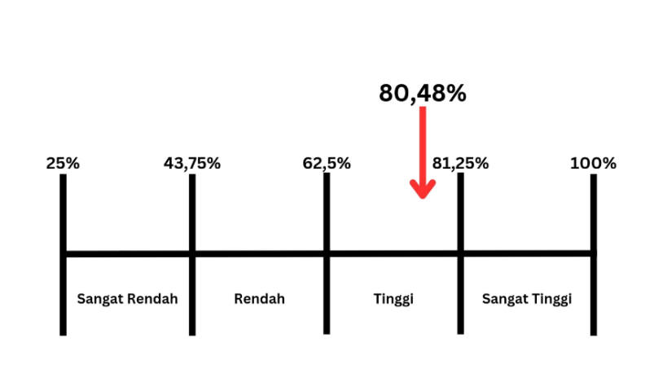
Figure 1. Main Facilities Continuum Line (Main Facilities)

Ideally, the expected score for respondents to answer 20 statements is 8000. The calculations in the table show that the score obtained is 6438 or 80.48% of the ideal score of 8000. Thus, Main Facilities are in the high or good category.
Respondents' responses regarding Support Facilities showed that the total score for Support Facilities was 5844. The total score is included in a continuum line, which can be seen in the image below:
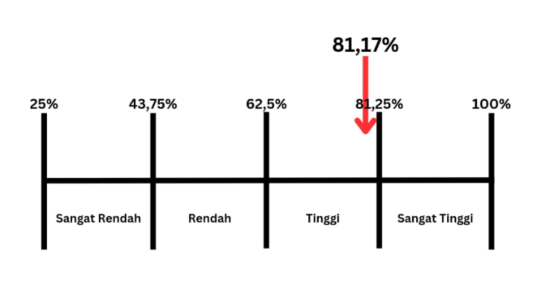
Figure 2. Support Facilities Continuum Line

Ideally, the expected score for respondents to answer the 18 statements is 7200. The calculations in the table show that the value obtained is 5844 or 81.17% of the ideal score of 7200. Thus, Support Facilities are in the high or good category.
Respondents' responses regarding Supporting Productive Activities (Activity Supporting Facilities) showed that the total score for Supporting Productive Activities (Activity Supporting Facilities) was 2332. The total score is entered into a continuum line, which can be seen in the image below:
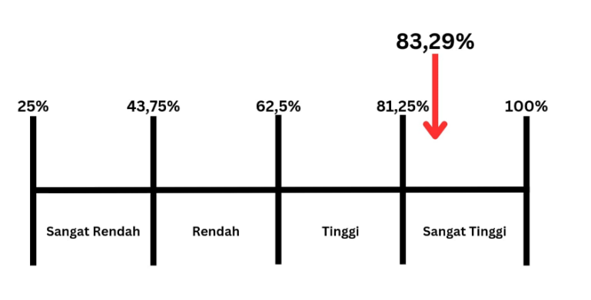
Figure 3. Supporting Productive Activities Continuum Line (Activity Supporting Facilities)

Ideally, the expected score for respondents to answer 7 statements is 2800. The calculations in the table show that the score obtained is 2332 or 83.29% of the ideal score of 2800. Thus, Supporting Productive Activities (Activity Supporting Facilities) is in the very high category or very good.
Respondents' responses regarding Destination Accessibilities (Tourist Attraction Achievement Facilities) showed that the total score for Destination Accessibilities (Tourist Attraction Achievement Facilities) was 676. The total score is included in a continuum line, which can be seen in the image below:
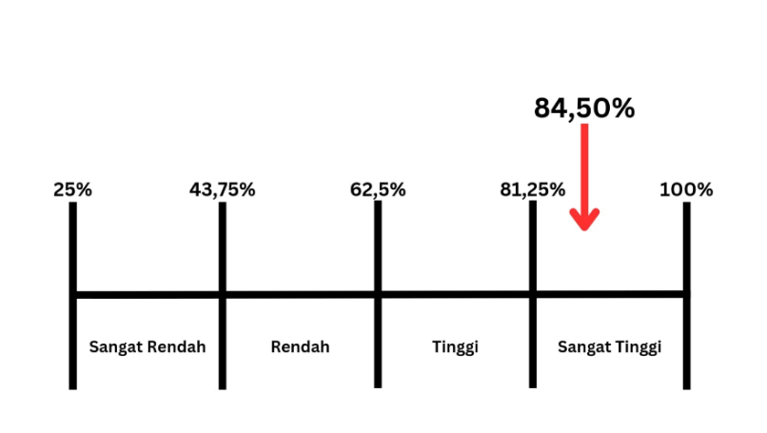
Figure 4. Destination Accessibilities Continuum Line (Tourist Attraction Achievement Facilities)

Ideally, the expected score for respondents to answer 2 statements is 800. The calculations in the table show that the score obtained is 676 or 84.50% of the ideal score of 800. Thus, Destination Accessibilities (Tourist Attraction Achievement Facilities) is in the very high category or very good.
Respondents' Responses Regarding Visitor Loyalty It was found that the total score for Visitor Loyalty was 1707. The total score is entered into a continuum line, which can be seen in the image below:
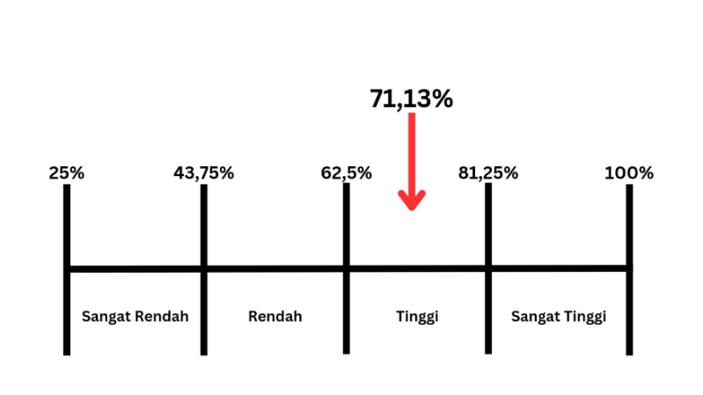
Figure 5. Destination Accessibilities Continuum Line (Facilities for Achieving Tourist Attractions)

Ideally, the expected score for respondents to answer the 6 statements is 2400. The calculations in the table show that the value obtained is 1707 or 71.13% of the ideal score of 2400. Thus, Visitor Loyalty is in the high or good category.

Classic assumption test
In carrying out the classic assumption test, the researcher used a data processing tool, namely IBM SPSS Statistics 25, so that the researcher could easily obtain data processing results from the questionnaire respondents that had been collected. The following is an analysis of the results of classical assumption testing using IBM SPSS Statistics25:
The normality test is a test used to see whether the independent variables and dependent variables used in this research are normally distributed or not. In this study, researchers used the Kolmogorov Smirnov technique , where a variable is said to be normally distributed if the significance value is > 0.05, conversely if a variable has a value < 0.05, then the variable is not normally distributed. The following are the results of the normality test using the Kolmogorov Smirnov technique via SPSS:
Table 3. Normality Test Results
One-Sample Kolmogorov-Smirnov Test
 |  |  | Unstandardized Residuals
N |  |  | 100
Normal Parameters ^{a, b} | Mean |  | .0000000
Normal Parameters ^{a, b} | Std. Deviation |  | 3.19628274
Most Extreme Differences | Absolute |  | ,140
Most Extreme Differences | Positive |  | .071
Most Extreme Differences | Negative |  | -.140
Statistical Tests |  |  | ,140
Asymp. Sig. (2-tailed) |  |  | ,000 ^{c}
Monte Carlo Sig. (2-tailed) | Sig. |  | .036 ^{d}
Monte Carlo Sig. (2-tailed) | 99% Confidence Interval | Lower Bound | .031
Monte Carlo Sig. (2-tailed) | 99% Confidence Interval | Upper Bound | .041
a. Test distribution is Normal.
b. Calculated from data.
c. Lilliefors Significance Correction.
d. Based on 10000 sampled tables with starting seed 2000000.
Source: Researcher's Process, 2024
Based on the table of One-Sample Kolmogorov-Smirnov Test normality test results above, if seen from the Monte Carlo Sig value. (2-tailed) namely 0.036, which is less than the significance value of 0.05. So it can be concluded that the distribution of the Tourism Facilities and Visitor Loyalty variables is not normally distributed.
The linearity test is a test used to evaluate whether the relationship between the independent variable and the dependent variable is linear or not. To carry out the linearity test in this research, the Test of Linearity was used . If the Sig value . if Deviation From Linearity is > 0.05, it can be concluded that there is a linear relationship between these variables. The results of the linearity test can be seen in the table below:

Table 4. Linearity Test Results
ANOVA Table
 |  |  | Sum of Squares | Df | Mean Square | F | Sig.
Loyalty * Tourist Facilities | Between Groups | (Combined) | 1341,031 | 52 | 25,789 | 3,065 | 0,000
Loyalty * Tourist Facilities | Between Groups | Linearity | 725,104 | 1 | 725,104 | 86,174 | 0,000
Loyalty * Tourist Facilities | Between Groups | Deviation from Linearity | 615,928 | 51 | 12,077 | 1,435 | 0.106
Loyalty * Tourist Facilities | Within Groups |  | 395,479 | 47 | 8,414
Loyalty * Tourist Facilities | Total |  | 1736,510 | 99
Source: Researcher's Process, 2024

Based on the test results table, it can be seen that the value of Deviation from Linearity is 0.106 where the value is >0.05. So it can be concluded that the relationship between the Tourism Facilities variable and Visitor Loyalty is a linear relationship.

The heteroscedasticity test is a test used to see whether there is an inequality of variance from the residuals of one observation to another. Heteroscedasticity detection can be done using the scatter plot method by plotting the ZPRED value (predicted value) with SRESID (residual value) . The research is said to have no symptoms of heteroscedasticity if the data points are spread above and below or around the number 0, the points do not gather only above or below, the distribution is not patterned, forming a wave pattern that widens then narrows and widens again and the points -The data points do not have any pattern. The following are the results of the heteroscedasticity test via SPSS which can be seen in the image below:

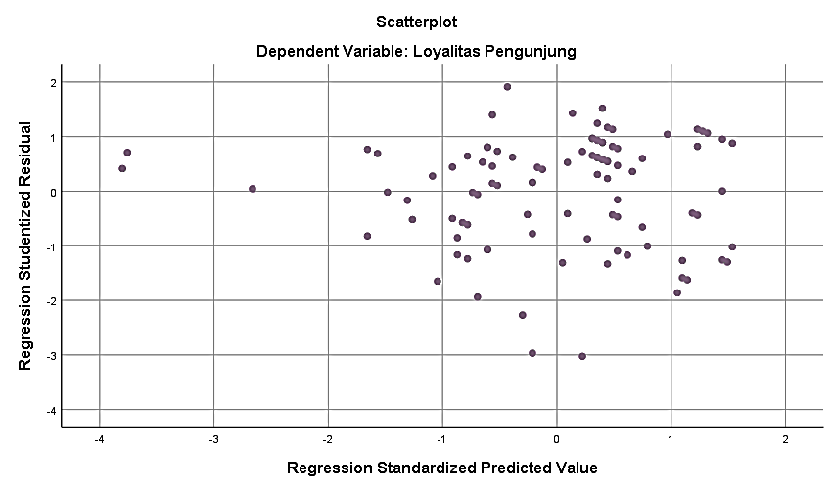
Figure 6. Heteroscedasticity Test Results
Source: Researcher's Process, 2024

It can be seen in the charts above that the distribution data is above and below or around the number 0, this data also has no pattern. So it can be concluded that the research does not experience heteroscedasticity.

Hypothesis testing
To carry out hypothesis testing, researchers used the IBM SPSS Statistics 25 application which can simplify and speed up the process of processing questionnaire data obtained from research respondents. The following is an analysis of the results of hypothesis testing via IBM SPSS Statistics 25:
The simple linear regression test is a test used to determine the relationship and magnitude of the influence of the independent variable on the dependent variable. The following are the results of the Simple Linear Regression Test via SPSS and the equations:
Table 5. Simple Linear Regression Test Results
ANOVA ª
Model |  | Sum of Squares | df | Mean Square | F | Sig.
1 | Regression | 725.104 | 1 | 725.104 | 70,259 | ,000 ^{b}
1 | Residual | 1011.406 | 98 | 10,320
1 | Total | 1736.510 | 99
a. Dependent Variable: Visitor Loyalty
b. Predictors: (Constant), Tourist Facilities
Source: Researcher's Process, 2024

From the output it is known that the calculated F value = 70.259 with a significance level of 0.000 < 0.05, so the regression model can be used to predict the participation variable or in other words there is an influence of the Tourism Facilities variable (X) on the Visitor Loyalty variable (Y).

The t test or partial test is a test used to determine the effect of each independent variable on the dependent variable. In this partial test, the significance value used is 0.05 or has a 95% chance of success and 5% chance of success. If the significance value of a variable is <0.05, then Ho is rejected or the independent variable has a partial influence on the dependent variable, but conversely if the significance value of a variable is >0.05, then Ho is accepted or the independent variable has no partial influence on the dependent variable. . The following are the results of the t test or partial test via SPSS:
Table 6. T-test results
Coefficients ª
Model |  | Unstandardized Coefficients |  | Standardized Coefficients | Q | Sig.
 |  | B | Std. Error | Beta | Q | Sig.
1 | (Constant) | -1,026 | 2,183 |  | -.470 | ,639
1 | Tourist Facilities | .118 | .014 | ,646 | 8,382 | ,000
a. Dependent Variable: Visitor Loyalty
Source: Researcher's Process, 2024

There are three ways to find out the results of the t test, namely based on the standard Beta coefficient, based on significance and based on the calculated T value. Based on the t test results table above, it can be seen that the standard Beta coefficient is 0.646, which means the influence of the Tourism Facilities variable is positive. Meanwhile, based on the significance of the Tourism Facilities variable, it is 0.000, where the significance value is less than 0.05, which means the influence of the Tourism Facilities variable is significant. And seen from T count, by T count > T table, T table is obtained from the amount of data - independent variables, which produces 100-1 = 99, then T table 99 with a significance used of 0.05 is 1.984. In the test results table, the calculated T value is 8.382 > T table 1.984, which means that the influence of the Tourism Facilities variable is significant on the Visitor Loyalty variable.

Coefficient of Determination Test
The coefficient of determination test is a test used to measure the ability of a regression model to explain variations in the dependent variable used. If the R2 value is between 0 (zero) and 1 (one), then the regression model can explain variations in the dependent variable well. The closer the R2 value is to 1 (one), the regression model can explain variations in the dependent variable as a whole, conversely, if the R2 value is closer to 0 (zero), then the regression model has limitations in explaining variations in the dependent variable. The following are the results of the coefficient of determination test via SPSS:

Table 7. Coefficient of Determination Test Results
Model Summary
Model | R | R Square | Adjusted R Square | Std. Error of the Estimate
1 | ,646 ª | ,418 | ,412 | 3,213

a. Predictors: (Constant), Tourist Facilities
Source: Researcher's Process, 2024
Based on the table of determination coefficient test results via SPSS above, if you look at the R Square value, it is 0.418, which means that the influence of tourist facilities on visitor loyalty is 41.8%.
Correlation Analysis
Correlation Analysis aims to determine the relationship between the influence of the tourist facility variable (X) on visitor loyalty (Y), determine the level of strength of the relationship between the tourist facility variable (X) and the visitor loyalty variable (Y), and determine the direction of the relationship between the two variables using the Rank correlation coefficient. Spearman calculated using SPSS to show the relationship between two variables on an interval scale. The following are the results of the Spearman Rank correlation analysis via SPSS:

Table 8. Correlation Analysis Test Results
Correlations
 |  |  | Tourist Facilities | Visitor Loyalty
Spearman's rho | Tourist Facilities | Correlation Coefficient | 1,000 | ,614 **
Spearman's rho | Tourist Facilities | Sig. (2-tailed) | . | ,000
Spearman's rho | Tourist Facilities | N | 100 | 100
Spearman's rho | Visitor Loyalty | Correlation Coefficient | ,614 ** | 1,000
Spearman's rho | Visitor Loyalty | Sig. (2-tailed) | ,000 | .
Spearman's rho | Visitor Loyalty | N | 100 | 100
**. Correlation is significant at the 0.01 level (2-tailed).
Source: Researcher's Process, 2024

Based on the output above, it is known that Sig. (2-tailed) of 0.000. Because the Sig (2-tailed) value is <0.05, it can be interpreted that there is a significant relationship between the Tourism Facilities variable (X) and the Visitor Loyalty variable (Y). A coefficient figure of 0.614 was also obtained, which can be interpreted as a strong level of correlation or relationship strength.

CONCLUSIONS

This research aims to find out how tourist facilities influence visitor loyalty to Transera Waterpark Bekasi City based on the urgency of this research, namely increasing awareness of Transera Waterpark regarding the importance of having good and well-maintained tourist facilities . The research results have answered the existing problem formulation.
In this study, researchers used the Tourism Facilities variable with 4 (four) dimensions, namely Main Facilities, Support Facilities, Supporting Productive Activities, Destination Accessibilities as independent variables. and using the Visitor Loyalty variable as the dependent variable. The type of research used by researchers is quantitative research and collecting sample data by distributing questionnaires to 100 people with the criteria of having visited Transera Waterpark Bekasi City and being 17 years old. The analytical method used is data quality testing in the form of Validity Test, Reliability Test. Classic Assumptions in the form of Normality Test, Linearity Test, Heteroscedasticity Test. Descriptive Analysis Test. Hypothesis testing in the form of Simple Linear Regression Test and t-test. Coefficient of Determination Test and Correlation Test.
Based on the results of the analysis, all indicators in this research are valid and reliable, in the classic assumption test the data obtained is not normally distributed, the relationship between the variables of Tourism Facilities and Visitor Loyalty is a linear relationship, and the research does not experience heteroscedasticity. In the descriptive analysis test, the Main Facilities dimension was in the high or good category, as were the Supporting Productive Activities dimensions , Destination Accessibilities (Tourist Attraction Achievement Facilities) and the Visitor Loyalty variable. Meanwhile, the Support Facilities dimension is in the very high or very good category. In the hypothesis test, there was an influence of the Tourism Facilities variable on Visitor Loyalty and the influence was declared significant. In the coefficient of determination test, the influence of tourist facilities on visitor loyalty was 41.8% and in the correlation test, a coefficient figure of 0.614 was obtained, which can be interpreted as the level of strength of correlation or strong relationship.

REFERENCES

Abdul Aziz, Z., Suprapto, H., Management Studies, P., & Economics and Business, Yogyakarta Veteran National Development University, F. (2020). The Influence of Visitor Facilities and Experience on Visitor Loyalty Mediated by Visitor Satisfaction (Survey of Umbul Ponggok Klaten Tourism Visitors). In Journal of Organizational Management Studies (Vol. 17, Issue 2). Https://Ejournal.Undip.Ac.Id/Index.Php/Smo/Article/View/32470
Ade Naftarisandy. (2019). The Influence of Tourist Facilities and Destination Image and Social Media Through Satisfaction on Consumers' Returning Interest in the Wurung Bondowoso Crater Tour . University of Jember.
Ajijah, J. H., & Selvi, E. (2021). The Influence of Competence and Communication on the Performance of Village Officials . 13 (2), 232–236.
Albar Alaydrus, Labandingi Latoki, & Zulkifl. (2020). The Influence of Promotion, Facilities and Location in Increasing Decisions to Visit the Millennium Waterpark Palu Baths. Journal of Trend Economics , 8 (1).
Amalia, R., & Sudibyo, AG (2020). The Influence of the No Straw Movement Public Relations Campaign on the Loyalty of Kona Koffie Visitors. Inter Script: Journal Of Creative Communication | , 2 (1), 73–85.
Andes Rahmat Fajrin, Gatot Wijayanto, & Sri Endang Kornita. (2021). The Influence of Facilities and Location on Satisfaction and Interest in Returning to Muara Takus Temple Tourists, Xiii Koto Kampar District, Kampar Regency. Journal of Economic Tips , Vol. 32 .
Candra, K., Heryanto, B., & Rochani, S. (2019). Analysis of the Influence of Wages, Education Level, Gender, and Age on Labor Productivity in the Ikat Weaving Industrial Sector in Kediri City. Jimek: Economic Student Scientific Journal , 2 (1), 38. Https://Doi.Org/10.30737/Jimek.V2i1.428
Dewi Purnama, P., & Dwi Milania, I. (2022). Performance Analysis of Supporting Facilities Assets at Dreamland Water Park Ajibarang, and Their Influence on Visitor Satisfaction. Performance Analysis of Supporting Facilities Assets at Dreamland Water Park Ajibarang, And Their Influence On Visitor Satisfaction. In Journal of Infrastructure & Facilities Asset Management (Vol. 6, Issue 2).
Dilla, N., Parimita, W., & Suherdi, S. (2023). The Influence of Work Motivation and Organizational Justice on Organizational Citizenship Behavior in PT Rickindo Employees. Sibatik Journal: Scientific Journal in Social, Economic, Cultural, Technological and Educational Sectors , 2 (2), 409–428. https://Doi.Org/10.54443/Sibatik.V2i2.567
Dini Mustika Damayanti. (2019). The Influence of Tourist Facilities on Satisfaction and Its Impact on Tourist Loyalty at Bumi Ayu Temple, Pali Regency . Sriwijaya State Polytechnic.
Husain, BA, & Santoso, AB (2023). The Influence of the Covid-19 Pandemic on the Number of Tourists Viewed from 4a (Attraction, Accessibility, Amenities, Amenities) Case Study of the Harapan Island Community. Journal of Management & Education , Vol.1 .
Ilham Raka Guntara, Tantri Puspita Yazid, & Rumyeni. (2023). Communication Strategy of the Family Planning Population Control Service for Women's Empowerment and Child Protection in Kampar Regency towards a Primary Level Child Friendly City. Public Service And Governance , 4 .
Mashuri, M. (2020). Analysis of Customer Loyalty Dimensions Based on an Islamic Perspective. Iqtishaduna: Our Scientific Journal of Economics , 9 (1), 54–64. https://Doi.Org/10.46367/Iqtishaduna.V9i1.212
Muslim, MBC (2022). The Influence of Attractions, Activities, Amenities and Accessibility on Tourist Satisfaction at Taman Nusa Bali. Journal of Management Vision , Vol.8 .
Nafiudin, Andari, Denny Kurnia, & Andini Tia Safitri. (2021). The Importance of Job Redesign and Job Descriptions to Improve Employee Performance During the Covid 19 Pandemic. Management Science , 7 .
Natanael Ariesandi Rusli, & Estika P Sani. (2022). The Influence of Team Work Supervision and Discipline on Employee Work Productivity of Pt. Primadaya Plasticindo. Journal of Management and Accounting Research , 2 (1).
Nurmala, Sullaida, & Damanhur. (2022). The Influence of Tourist Facilities, Tourist Attraction and Service Quality on Visitor Satisfaction at Ujong Blang Lhokseumawe Beach Tourism. Journal of Management and Business Economics , 22 .
Olivia, J., & Nurfebiaraning, S. (ND). The Influence of Tokopedia's Video Advertising Version "Make Ramadan the Best Opportunity" on Audience's Affective Response (Vol. 7).
Pariyanti, E., & Buchori, R. (ND). Tourist Attractions and Business Actors (The Impact of Tourist Attraction Development on the Community's Economy) . Www.Pustakaaksara.Co.Id
Pratama, SA, Intan, R., Student, P., Lecturer, D., & Unsurya, M. (ND). The Effect of Implementing Standard Operational Procedures and Competencies on the Work Productivity of Employees of the Export Division of Pt. Two Indonesian Horses .
Priska Regina E. Mamesah. (2020). The Influence of Service Quality on Customer Satisfaction at the Lucky Inn Manado Hotel .
Prof. Dr. Sugiyono. (2019). Quantitative Qualitative Research Methods and R&D (2nd Ed.). Alphabet.
Purnomo, E., & Suhendra, ES (2020). Analysis of Years of Service and Promotions on the Performance of BPJS Employment Employees. Archipelago Journal of Business Management Applications , 5 (1), 32–43. https://Doi.Org/10.29407/Nusamba.V5i1.13801
Rorong, GA, Tamengkel, LF, Mukuan, DDS, Studi, P., & Bisnis, A. (2021). The Influence of Price and Product Quality on Purchasing Decisions on Imported Used Clothing at Pasar Baru Langowan. In Productivity (Vol. 2, Issue 3).
Septiawan, J. (2021). Identification of Facilities and Infrastructure for the Comfort of Embung Cerme Tourism Users, Sanggang Village .
Syaiful Anwar, R., Ikhwan, S., Khojin, N., Program, S., Management, F., Economics, D., Business, UM, Setiabudi, K., Brebes, J., & Tengah, I. (ND). The Influence of Customer Relationship Management on Customer Loyalty Through Customer Satisfaction (Case Study at He Kafei Coffee Shop). In Indonesian Journal of Research and Community Service (Vol. 1, Issue 1).
Tia Nur Safitri. (2021). The Influence of Service Quality, Facilities and Customer Satisfaction on Batam City Hotel Customer Loyalty . Putera Batam University.
Transera Waterpark . (ND). Retrieved September 20, 2023, From Www.Transerawaterpark.Co.Id
Virginia Saway, W., Alvianna, S., Lasarudin, A., & Hidayatullah, S. (ND). The Impact of Attractions, Amenities and Accessibility of Pasir Putih Beach, Manokwari Regency on the Satisfaction of Visiting Tourists . Http://Ejournal.Ihdn.Ac.Id/Index.Php/Pb/Index
Wahyudi, AS, Sukowiyono, G., & Hamka. (2023). Waterpark and Hotel Tourism in Batangan Village, Bangkalantema Regency: Tropical Architecture. Pengilon Journal , Volume 7 .
Wulandari, RW, Sidanti, H., Citaningtyas, D., & Kadi, A. (ND). Simba Business Management and Accounting Innovation Seminar 4 Business Management and Accounting Innovation Seminar (Simba) 4 Faculty of Economics and Business Pgri Madiun University The Influence of Tourist Facilities, Price Perceptions, and Destination Image on Interest in Returning to Lawu Park Tawangmangu Tourism, Karanganyar Regency, Central Java .
Yana Riza, F., Antosa, Z., & Witri, G. (ND). Journal of Elementary School Education and Learning Innovation Developing Multicultural Based Student Worksheets in Arts, Culture and Crafts Learning for Class V Elementary Schools . Http://E-Journal.Unp.Ac.Id/Index.Php/Jippsd
Yuliana, L., Nim, R., Ekonomi, J., Faculty, S., Dan, E., & Islam, B. (2023). The Influence of Facilities and Tourist Attractions on Visitor Loyalty at the Ngebel Lake Tourist Attraction, Ponorogo Thesis by .
Z. Novandaya, & HB Wijaya. (2021). The Influence of Supply Factor Satisfaction Values on Visitor Loyalty at Posong Tourist Attractions. Pwk Engineering (City Regional Planning) .

