MANUSCRIPT TEMPLATE
AGRARIS: JOURNAL OF AGRIBUSINESS AND RURAL DEVELOPMENT RESEARCH

Manuscript Submission Criteria:
- The manuscript is a result of the agribusiness and rural development research. The manuscript should have a novelty/authenticity contribution or uniqueness for academic (science) development.
- The manuscript contains original research work, free from plagiarism and other unethical attitudes.
- The author must ensure that the manuscript has not been published in the other periodical journals at the time of manuscript submission.

General Requirement:
- Written in Microsoft Word version 2003 to 2016
- Written in English and strongly suggested to proofread.
- Refers to Manuscript Writing Guidelines
- Font Times New Roman size 12 and line spacing 1.5, 15-20 pages
- The similarity level should be less than 15%
- Write the currency code in international standard
- Write in italic for non-English terms.

This template is a guideline for the author in adjusting CONTENT and FORMAT of the manuscript that will be submitted to AGRARIS.

Title (Brief, Describe the Uniqueness of The Research, And Up To 20 Words, Each Word Should Begin with Capitalized Letter)

First Author’s Name^{1*}, Second Author², Third Author³
¹First author’s affiliation, Address, City, Country
² Second author’s affiliation, Address, City, Country
³Third author’s affiliation, Address, City, Country
Correspondence email: author@email.com

ABSTRACT
Abstract is a mini version of a paper written in English. Abstract is formatted in one paragraph with single line spacing and a maximum of 250 words. The abstract should contain a clear statement of (i) a brief description of the background (maximum two sentences), (ii) the aims of research, (iii) methods, and (iv) the main result and conclusion. Abstract does not contain any reference or formula.

Keywords: 3- 5 words or phrases that reflect the content of the article (alphabetically)

INTRODUCTION
The manuscript is written in good English. Make sure that both the grammatical and spelling of your manuscript are correct. The introduction is written without numbers and/or pointers. This introduction provides the rationales of this study. This section consists of (i) nature and scope of the problem in a broader (national, regional, international) context, (ii) review of relevant literature, (iii) significance/novelty/contribution of this research on knowledge, (iv) aims of this research. If there is a hypothesis, declare it explicitly and not in an interrogative sentence. It should be written efficiently and supported by references. Extensive discussion of relevant literature should be included in the discussion, not in the introduction.

RESEARCH METHOD
This section should explain how the research was conducted. It should be written clearly and completely containing a clear description of (i) population and sampling, (ii) data measuring and collecting, (iii) variable and data analysis. This research method should be sufficiently detailed to reproduce the described procedure. For qualitative research, please adjust this method to the scientific writing habits while considering the repeatability of the research. It was unnecessary to write common analysis methods (e.g., F-test formula, t-test), but just refer to your source. References of original methods/procedures must be stated, and all modifications of procedures (if any) should be explained. Symbol description of the model was suggested to be written on narration.

RESULTS AND DISCUSSION
In the beginning, this RESULTS AND DISCUSSION section presented the results. Data should be presented in Tables or Figures when feasible. There should be no duplication of data in Table and Figure. The table should be clear and stand-alone, giving complete information without text. The title of Table and Figure should briefly and clearly describe the described facts. Symbols written in Table and Figure should be given complete information and allow the reader to interpret the results of the experiment. The narration should elaborate on the tabular data, but numbers should not be repeated extensively within this narration. Each Figure and Table must be referred to in the narration.
In the rest of this RESULTS AND DISCUSSION section, the author must discuss the research findings. The discussion showed to the reader the relationship among the results and put these results in previous research. Discussion should be relevant to the results, address logical explanations of the research findings, and be supported with relevant literature. The discussion should explain how the results agree or disagree with the previous study and why. It was strongly suggested to describe the advantage (novelty) of your research findings compared to other research mentioned in the introduction.
Subtitle Subtitle Subtitle
Sub-subtitle sub-subtitle sub-subtitle

Table 1. Summary of Author Guideline
Section | Description
General | Written in good English throughout manuscript  Make sure that both grammatical and spelling correct
Title | Describe the uniqueness of research  Not exceed 20 words
Author’s name Affiliation | Without academic title  Affiliation should be written completely (department and country)
Abstract | One paragraph and single spacing  Max 250 words  Consist of the research background (maximum two sentences), aims, methods, main results, and conclusion.
Keyword | 3-5 words or phrases, arrange alphabetically
Introduction | Consists of:  - Problem in a broader (national, regional, international) context  - Review of relevant literature and the significance/novelty/contribution  - Aims of this research
Main Research Method | Explain how the research was conducted and must repeatable  Should be a clear description of  - Population and sampling,  - Variable measuring and data collecting  - Data analysis.
Result and Discussion | The beginning of this section presents result and findings  Data should be presented in Tables or Figures  The results answer the research questions  The In the rest this section must discuss findings (how and why) based on previous research
Tables and Figures | Should be clear and stand-alone, tell by their self  Giving complete information without text  Title should write briefly and uniquely  Must be referred to in the text  Use font style Futura Lt Bt
Conclusion | Summarizes the principal findings and answer the aim of research  Written in paragraph  Showed significance of the results/findings or practical application
References | Apply APA 6th Edition style  Prior to articles which published reputable journal on the last 10 years  Online available and traceable  Min. 40 titles (30 titles are published by reputable international journal)

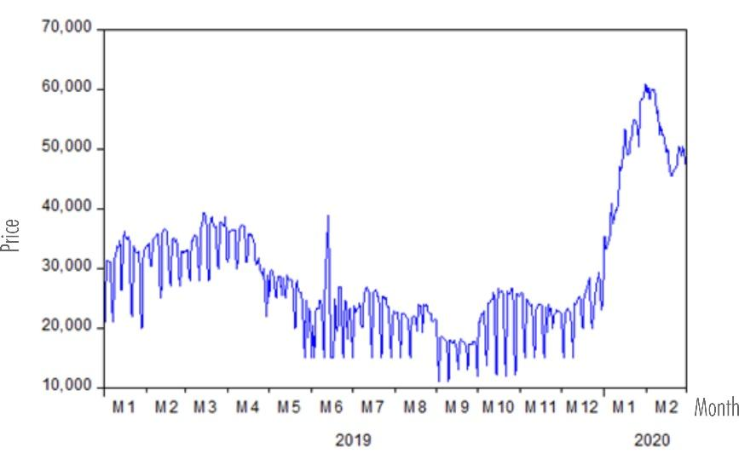
Figure 1. Development of The Red Chili Price in Semarang Regency (2019-2020)
Note: Images must be clear and high resolution (not broken)
CONCLUSION AND RECOMMENDATION
The conclusion summarizes the principal findings. This conclusion is written briefly. Conclusion related to the introduction and aims or hypothesis but did not repeat the discussion. Conclusion written critically, logically, and honestly based on the existing fact, and full of cautions if there was a generalization. A recommendation showed the significance of the results/findings or practical application of these findings. This section, written in paragraph form, does not use numbering or bullets.

Acknowledgments (If Necessary): This section provided the authors with gratitude to the research funder, facility, or suggestion and for the statement if the article is part of the thesis/dissertation.
Author contributions: for articles with several authors, please write each author's contribution in a brief paragraph. The authorship must be limited to those who have contributed, besides reading and agreeing on the final manuscript.
Conflict of interest: The author should declare the conflict of interest or state "the authors declare no conflict of interest." The author must identify and state the circumstances that may be considered to influence the interpretation of the research results.

REFERENCES
The reference contains the list of journals, books, or other publications referred to in this manuscript. Each reference cited in the text must be listed in REFERENCES and vice versa. References of the manuscript must be traceable, no less than 40 and consist of a minimum 30 from International Reputable Journal (E.g.: Scopus Indexed Journal), should be a primary source (80%), and not exceed 10 years (80%). The AGRARIS follows the American Psychological Association (APA) 6th Edition. The reference writing was strongly suggested using Mendeley References Manager, as well as writing source of references. Some examples are (Debertin, 2004); (Statistics Indonesia, 2020); (Triyono, Kamardiani, & Prasetio, 2021); (Wong, Sharifuddin, Teng, Li, & Song, 2020).

Here are examples of references:

Debertin, D. L. (2004). Agricultural Production Economics (Second Edi). New Jersey: Pearson Education.

Statistics Indonesia. (2020). The Statistics of Farm Wages in Rural Area. Jakarta: BPS-Statistics Indonesia.

Triyono, Kamardiani, D. R., & Prasetio, M. A. (2021). Allocative Efficiency of Honey Pineapple Farm in Pemalang Regency, Central Java, Indonesia. In Juwaidah, P. Saiyut, M. M. Tjale, & Z. Rozaki (Eds.), International Conference on Agribusiness and Rural Development (IConARD 2020) (Vol. 232, p. 01016). E3S Web of Conferences. https://doi.org/10.1051/e3sconf/202123201016

Wong, K. K. S., Sharifuddin, J. B., Teng, P. K., Li, W. W., & Song, L. K. (2020). Impact of Urban Consumers Food Consumption Behavior Towards Food Waste. AGRARIS: Journal of Agribusiness and Rural Development Research, 6(2), 198–207. https://doi.org/https://doi.org/10.18196/agr.62100

